Productivity growth vs:
union decline manufacturing decline

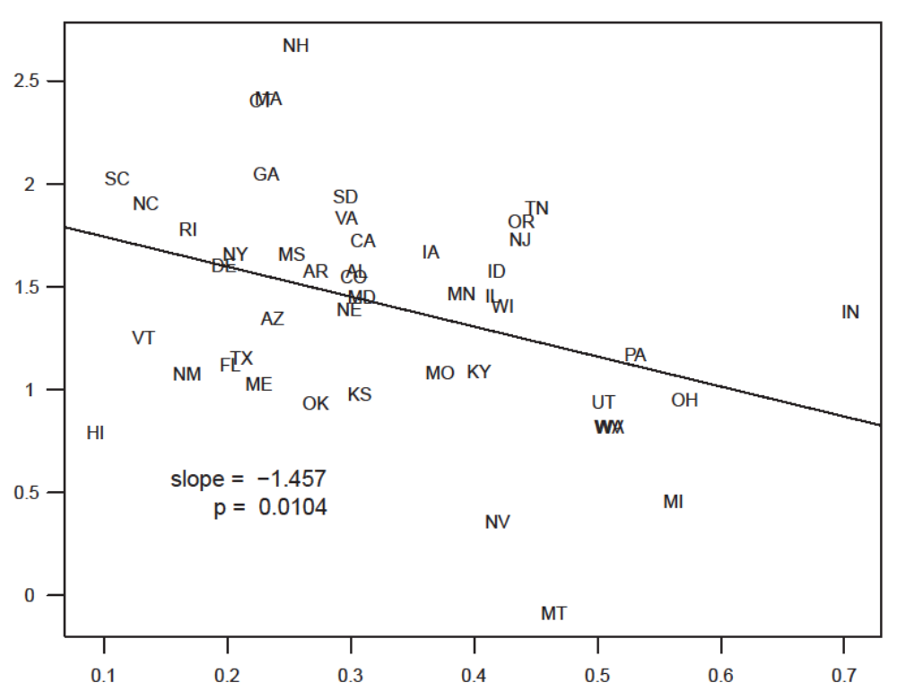
1964 - 2010
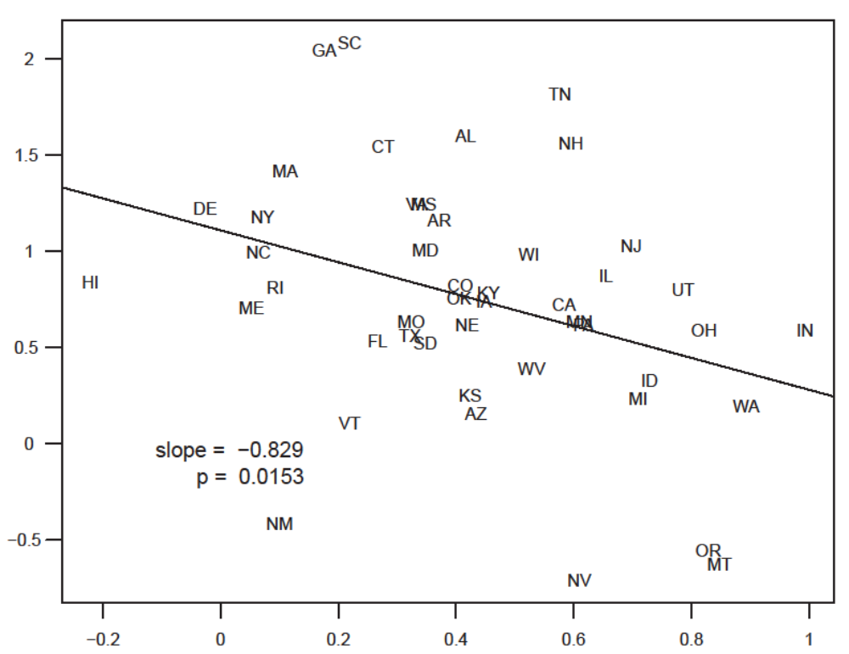
1964 - 1984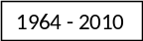84

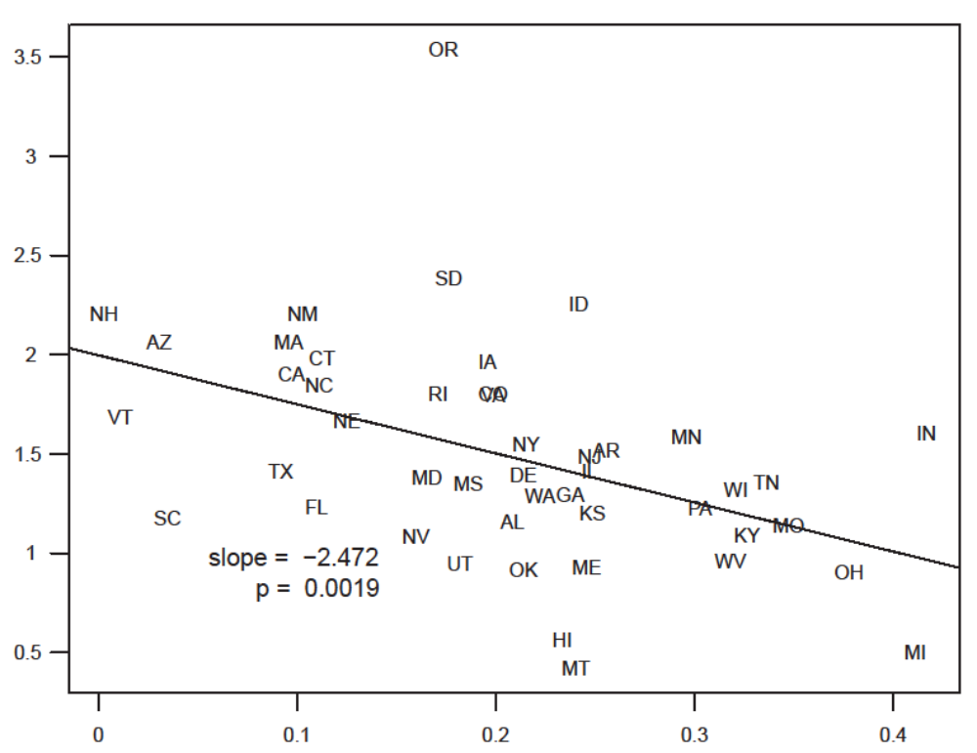
1985 - 201084
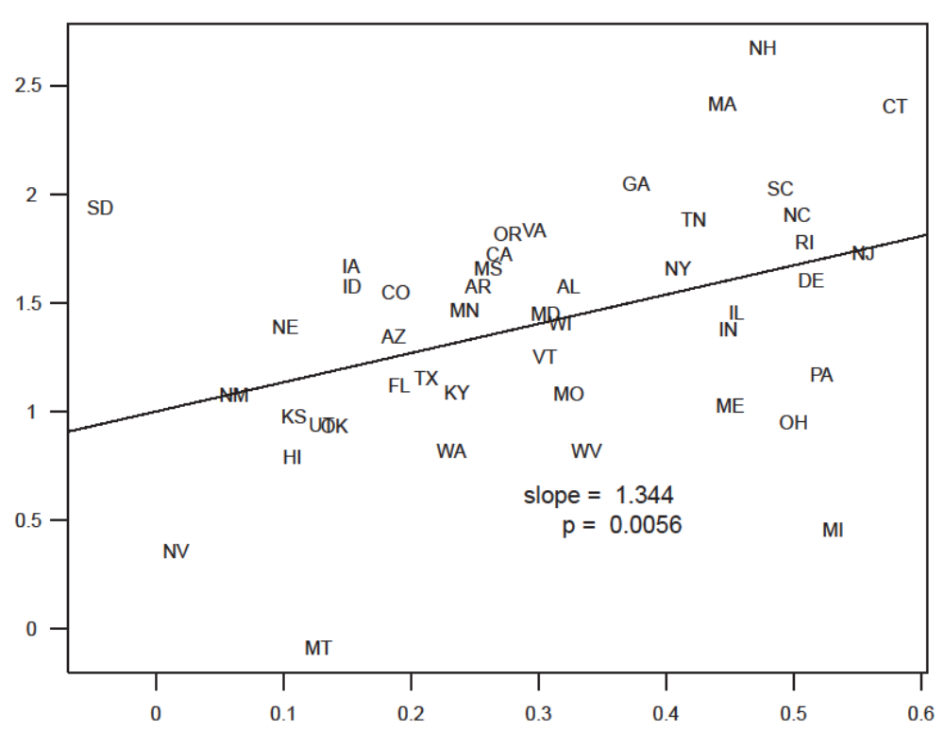
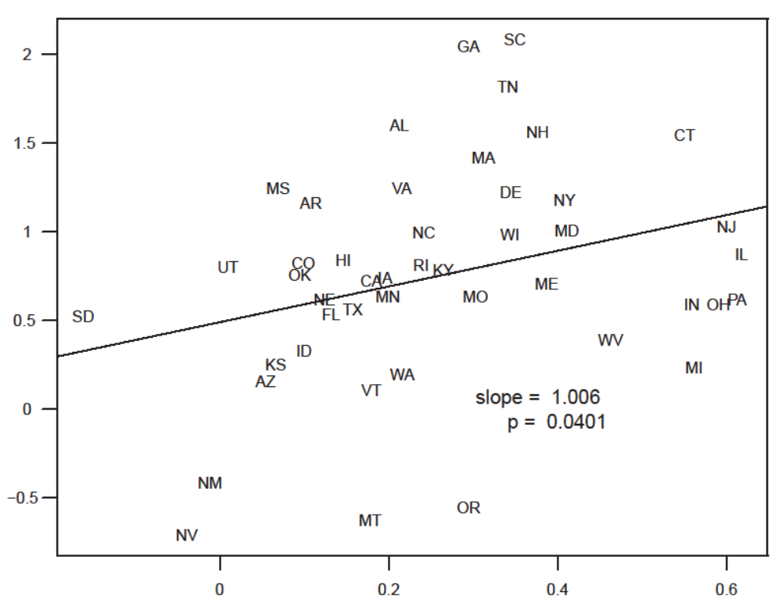

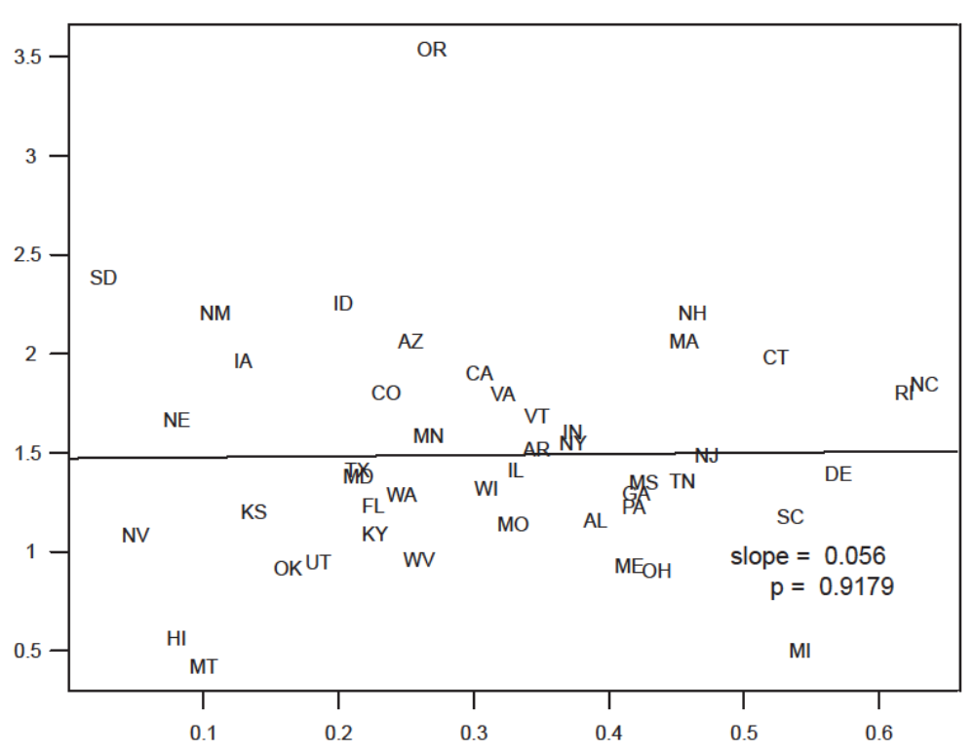

Note: See Figures for data and details.

Figure 1 1969 – 2010 Productivity growth versus union decline

Notes: Excludes outlier states: Alaska, North Dakota, Louisiana and Wyoming. Average annual percent change in productivity versus average annual percentage point decrease in union share. Data for each state for 1969-1971 are averaged to provide initial productivity and union share values. Data for each state for 2008-2010 are averaged to provide final productivity and union share values. The values in this figure are the difference between the final and initial values divided by 40, i.e., the number of years from the beginning of the period to the end (1970 to 2009 due to the three year averages used for the final and initial values). State productivity is measured as the ratio of real gross domestic product (RGDP) and the total number of employees.

Sources: Total state/year employment: State Annual Personal Income, SA27; Wage and salary employment by industry, Bureau of Economic Analysis, U.S. Department of Commerce: bea.gov/regional/spi/. For methodology information, see: bea.gov/regional/pdf/spi2010.pdf. For RGDP and union data sources and details, see…………………………

Figure 2 1969 – 2010 Productivity growth versus manufacturing decline
Notes: Excludes outlier states: Alaska, North Dakota, Louisiana and Wyoming. Average annual percent change in productivity versus average annual percentage point decrease in union share. Data for each state for 1969-1971 are averaged to provide initial productivity and manufacturing share values. Data for each state for 2008-2010 are averaged to provide final productivity and manufacturing share values. The values in this figure are the difference between the final and initial values divided by 40, i.e., the number of years from the beginning of the period to the end (1970 to 2009 due to the three year averages used for the final and initial values). State productivity is the ratio between real gross domestic product (RGDP) and the total number of employees.

Sources: Total state/year employment: State Annual Personal Income, SA27; Wage and salary employment by industry, Bureau of Economic Analysis, U.S. Department of Commerce: bea.gov/regional/spi/. For methodology information, see: bea.gov/regional/pdf/spi2010.pdf. For RGDP and manufacturing data sources and details, see…………………………

Figure 3 1969 – 1984 Productivity growth versus union decline
Notes: Excludes outlier states: Alaska, North Dakota, Louisiana and Wyoming. Average annual percent change in productivity versus average annual percentage point decrease in union share. Data for each state for 1969-1971 are averaged to provide initial productivity and union share values. Data for each state for 1983-1985 are averaged to provide final productivity and union share values. The values in this figure are the difference between the final and initial values divided by 15, i.e., the number of years from the beginning of the period to the end (1970 to 1984 due to the three year averages used for the final and initial values). State productivity is measured as the ratio of real gross domestic product (RGDP) and the total number of employees.

Sources: Total state/year employment: State Annual Personal Income, SA27; Wage and salary employment by industry, Bureau of Economic Analysis, U.S. Department of Commerce: bea.gov/regional/spi/. For methodology information, see: bea.gov/regional/pdf/spi2010.pdf. For RGDP and union data sources and details, see …………………………

Figure 4 1969 – 1984 Productivity growth versus manufacturing decline

Notes: Excludes outlier states: Alaska, North Dakota, Louisiana and Wyoming. Average annual percent change in productivity versus average annual percentage point decrease in manufacturing share. Data for each state for 1969-1971 are averaged to provide initial productivity and manufacturing share values. Data for each state for 1983-1985 are averaged to provide final productivity and manufacturing share values. The values in this figure are the difference between the final and initial values divided by 15, i.e., the number of years from the beginning of the period to the end (1970 to 1984 due to the three year averages used for the final and initial values). State productivity is measured as the ratio of real gross domestic product (RGDP) and the total number of employees.

Sources: Total state/year employment: State Annual Personal Income, SA27; Wage and salary employment by industry, Bureau of Economic Analysis, U.S. Department of Commerce: bea.gov/regional/spi/. For methodology information, see: bea.gov/regional/pdf/spi2010.pdf. For RGDP and manufacturing data sources and details, see …………………………

Figure 5 1984 – 2010 Productivity growth versus union decline
Notes: Excludes outlier states: Alaska, North Dakota, Louisiana and Wyoming. Average annual percent change in productivity versus average annual percentage point decrease in union share. Data for each state for 1985-1987 are averaged to provide initial productivity and union share values. Data for each state for 2008-2010 are averaged to provide final productivity and union share values. The values in this figure are the difference between the final and initial values divided by 24, i.e., the number of years from the beginning of the period to the end (1986 to 2009 due to the three year averages used for the final and initial values). State productivity is measured as the ratio of real gross domestic product (RGDP) and the total number of employees.

Sources: Total state/year employment: State Annual Personal Income, SA27; Wage and salary employment by industry, Bureau of Economic Analysis, U.S. Department of Commerce: bea.gov/regional/spi/. For methodology information, see: bea.gov/regional/pdf/spi2010.pdf. For RGDP and union data sources and details, see …………………………

Figure 6 1984 – 2010 Productivity growth versus manufacturing decline
Notes: Excludes outlier states: Alaska, North Dakota, Louisiana and Wyoming. Average annual percent change in productivity versus average annual percentage point decrease in manufacturing share. Data for each state for 1985-1987 are averaged to provide initial productivity and manufacturing share values. Data for each state for 2008-2010 are averaged to provide final productivity and manufacturing share values. The values in this figure are the difference between the final and initial values divided by 24, i.e., the number of years from the beginning of the period to the end (1986 to 2009 due to the three year averages used for the final and initial values). State productivity is measured as the ratio of real gross domestic product (RGDP) and the total number of employees.

Sources: Total state/year employment: State Annual Personal Income, SA27; Wage and salary employment by industry, Bureau of Economic Analysis, U.S. Department of Commerce: bea.gov/regional/spi/. For methodology information, see: bea.gov/regional/pdf/spi2010.pdf. For RGDP and union data sources and details, see …………………………

Figure 7 Summary of Figures 1, 3 and 5
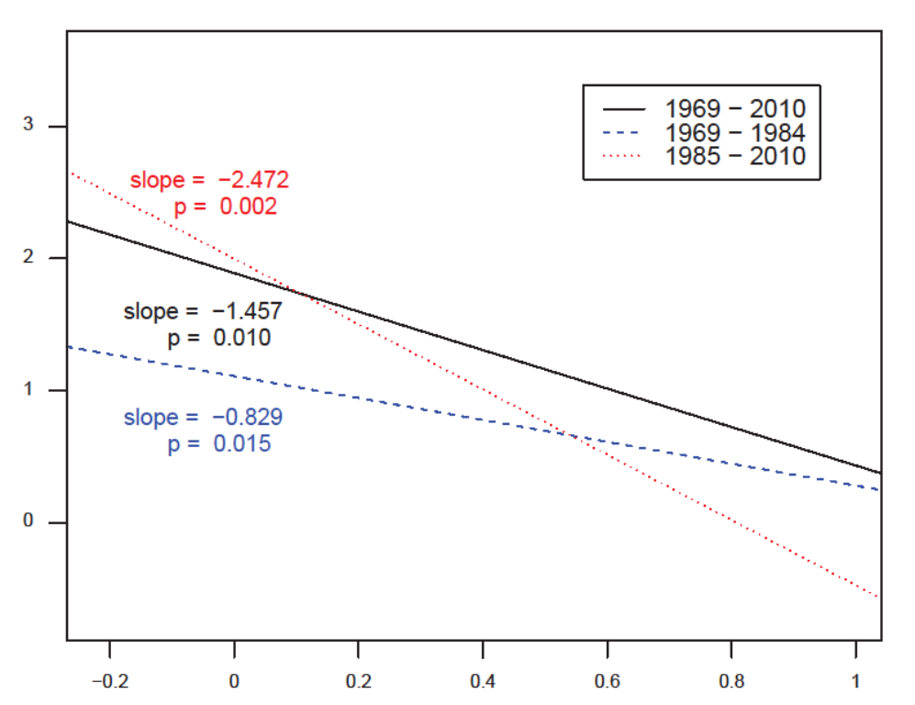
Note: See Figures for details and sources.

Figure 8 Summary of manufacturing decline versus union decline regression
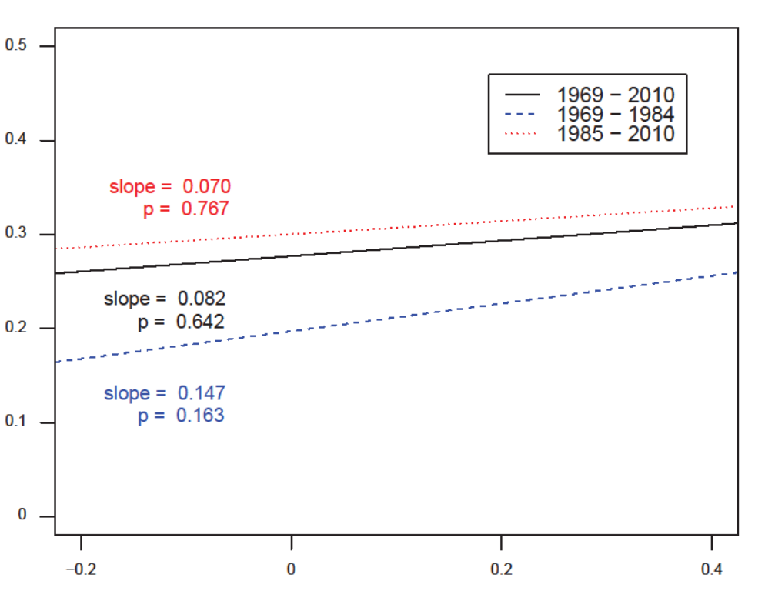
Note: See Figures for details and sources.
Table 1 Summary statistics
 | State average annual |  |  | mean | sd | min | max
 | Productivity Growth
 | 1969 - 2010 |  |  | 1.409 | 0.538 | -0.085 | 2.672
 | 1969 - 1984 |  |  | 0.752 | 0.626 | -0.709 | 2.082
 | 1985 - 2010 |  |  | 1.489 | 0.558 | 0.422 | 3.537
 | Union decline
 | 1969 - 2010 |  |  | 0.329 | 0.138 | 0.093 | 0.705
 | 1969 - 1984 |  |  | 0.430 | 0.269 | -0.221 | 0.993
 | 1985 - 2010 |  |  | 0.206 | 0.100 | 0.003 | 0.417
 | Manufacturing decline
 | 1969 - 2010 |  |  | 0.304 | 0.161 | -0.044 | 0.580
 | 1969 - 1984 |  |  | 0.261 | 0.189 | -0.162 | 0.618
 | 1985 - 2010 |  |  | 0.315 | 0.156 | 0.026 | 0.633
Note: See Figures for details and sources.

Table 2 Effect of union decline and manufacturing decline on productivity growth
 | Productivity growth |  | 1969 to 2010 |  | 1969 to 1984 |  | 1985 to 2010
 |  |  |  | (1) |  | (2) |  | (3)
 | Intercept |  |  | 1.491*** |  | 0.850*** |  | 1.959***
 | SE |  |  | (0.209) |  | (0.176) |  | (0.227)
 | Decline in union share |  |  | -1.575*** |  | -1.021*** |  | -2.481***
 | SE |  |  | (0.489) |  | (0.309) |  | (0.76)
 | Decline in manufacturing share |  |  | 1.439*** |  | 1.310*** |  | 0.128
 | SE |  |  | (0.419) |  | (0.44) |  | (0.489)
 | R² |  |  | 0.293 |  | 0.242 |  | 0.162
Note: See Figures for details and sources.

